Task 5

SQL (Structured Query Language) is a language used to interact with relational databases. SQL data types define the type of data that can be stored in a database column or variable. Here are the most common SQL data types:

1. Numeric data types: These are used to store numeric values. Examples include INT, BIGINT, DECIMAL, and FLOAT.
2. Character data types: These are used to store character strings. Examples include CHAR, VARCHAR, and TEXT.
3. Date and time data types: These are used to store date and time values. Examples include DATE, TIME, and TIMESTAMP.
4. Binary data types: These are used to store binary data, such as images or audio files. Examples include BLOB and BYTEA.
5. Boolean data type: This data type is used to store logical values. The only possible values are TRUE and FALSE.
6. Interval data types: These are used to store intervals of time. Examples include INTERVAL YEAR, INTERVAL MONTH, and INTERVAL DAY.
7. Array data types: These are used to store arrays of values. Examples include ARRAY and JSON.
8. XML data type: This data type is used to store XML data.
9. Spatial data types: These are used to store geometric or geographic data. Examples include POINT, LINE, and POLYGON.

Different databases may have different variations of these data types, or they may have additional data types not listed here. Understanding SQL data types is important for creating tables and working with data in a database, as it affects how data is stored and processed.

Like in other programming languages, SQL also has certain datatypes available. A brief idea of all the datatypes are discussed below.

1. **Binary Datatypes :** There are four subtypes of this datatype which are given below:

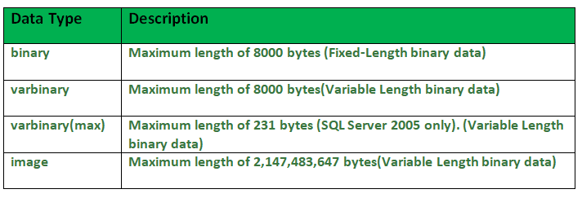

2. **Exact Numeric Datatype :** There are nine subtypes which are given below in the table. The table contains the range of data in a particular type.

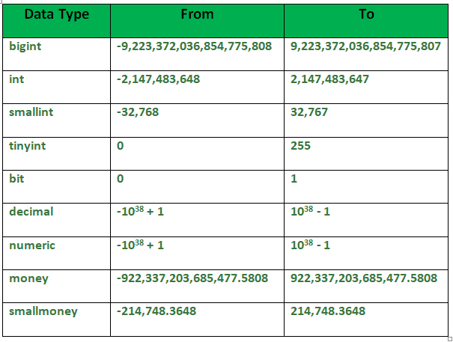

**3. Approximate Numeric Datatype :** The subtypes of this datatype are given in the table with the range.

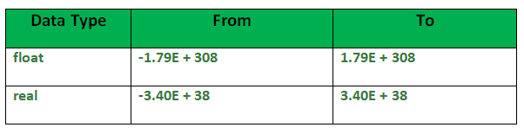 **4. Character String Datatype :** The subtypes are given in below table – 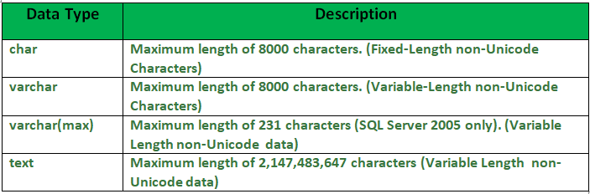

**5. Unicode Character String Datatype :** The details are given in below table – 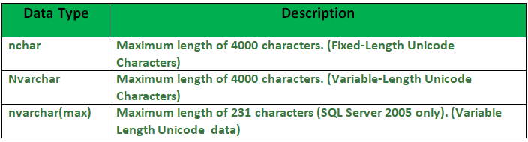

**6. Date and Time Datatype :** The details are given in below table.

